**ASSIGNMENT 25.1**

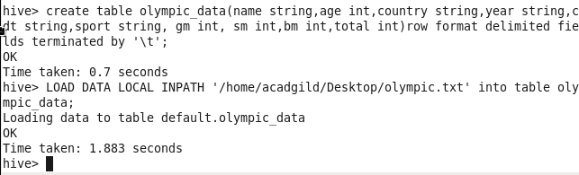

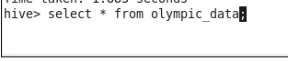

**DATASET:**

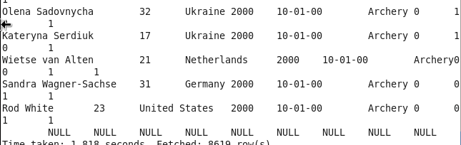

1. **Write a Hive program to find the number of medals won by each country in swimming.**

Count of total medals for swimming according to country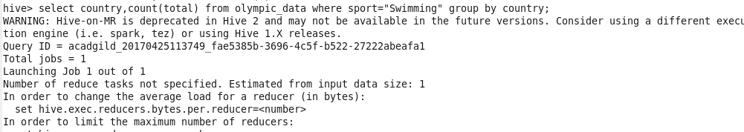

Result

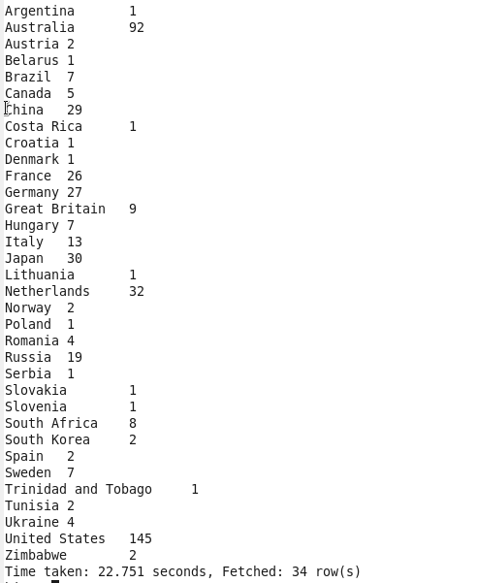

**2) : Write a Hive program to find the number of medals that India won year wise.**

Count of total number of medals according to year

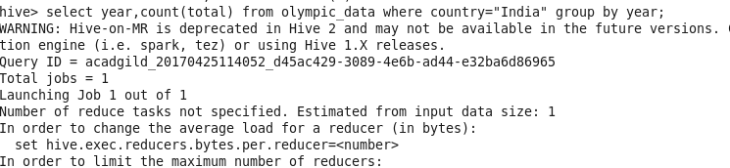

Result

